Architecture And Design
For
AR Office Using Magic Leap
V1.0

Contributors
Name | Function | Email
Oscar Reynhout | Consultant  Technology & Innovation Operations Manager 1 | oscar.reynhout@ict.nl
Joris van Liempd | Technical Specialist  Medewerker Technology & Innovation OM 1 | joris.van.liempd@ict.nl
Samer Boules | Software Engineer | samer.boules@ict.nl

Table of Contents

Revision History 3
1 Introduction 4
1.1 Overview 4
System Design 5
1.2 RUUVI Tags 5
1.3 Feature 002: Persistence 5
1.4 Feature 003: Interaction 5

Revision History
Version | Date | Name | Description
v1.0 | 14 March 2019 | Initial Creation | - Create document template  - Add system design section

Introduction

Overview
This document describes the technical specifications of the project. System overview, and software modules can all be explained here.

System Design

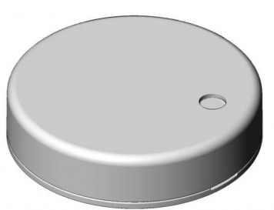
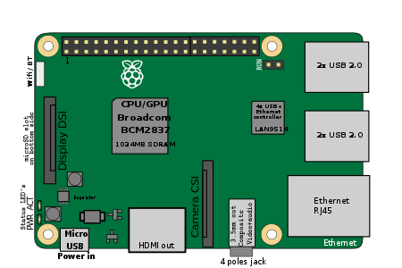

The core requirements of the system are listed in this section. Features are system behaviors from the user’s point-of-view. The requirements of a feature are described by one or more use cases plus any additional narration that is necessary.

RUUVI Tags

Raspberry Pi

CONNXT

Magic Leap

